**Full Stack Development with MERN**

**Frontend Development Report**

|  |  |
| --- | --- |
| Date | 12 July 2024 |
| Team ID | SWTID1719933836 |
| Project Name | Connectify |
| Maximum Marks |  |

**Project Title: Connectify**

Date: 12 July 2024

Prepared by: Aakarsh Sinha

**Objective**

The objective of this report is to document the frontend development progress and key aspects of the user interface implementation for the Connectify project.

**Technologies Used**

* **Frontend Framework:** ReactJS, Tailwind
* **State Management:** Local State (Hooks)
* **UI Framework/Libraries:** Bootstrap, React Router
* **API Libraries:** mongoose, socket.io, axios, body-parser, cors, JWT(jsonwebtoken), express-validator, Postman

**Project Structure**

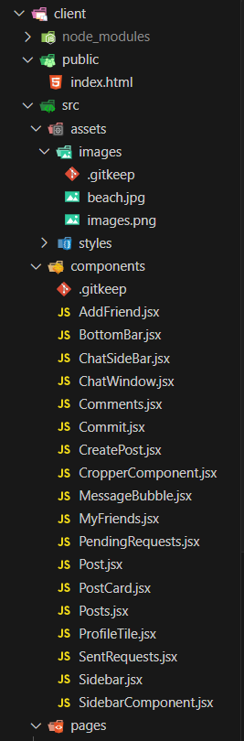

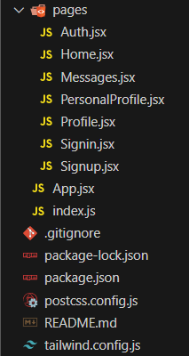

**Key Components**

1. **App.jsx**
   * Responsible for routing and main application layout.
2. **/components**
   * Contains reusable UI components used across the application.
3. **/pages**
   * Includes different pages for Web App.

**Routing**

Routing is managed using React Router. Here are the main routes:

* **/** - Landing page of the application.
* **/signup** – Sign Up page
* **/signin** – Sign In page
* **/home** – The user’s home page
* **/addfriend** – Adding friends for a user
* **/myfriends** – Display the user’s friend list
* **/pendingrequests** – Displays the pending friend requests
* **/sentrequests** – Displays friends requests sent by user
* **/personalprofile** – User profile management
* **/messages** – Chat dialogue of the user

**State Management**

State management is achieved using Local State (Hooks).

**Integration with Backend**

The frontend communicates with the backend APIs hosted on http://localhost:5000/api. Key endpoints include:

* **GET /api/users/getusers** – Retrieves list of users
* **GET /api/users/getfriends** – Retrieves list of friends
* **POST /api/user/login** - Handles user authentication.

**User Interface (UI) Design**

* The UI design follows a [describe design principles].
* Implemented using [UI framework/library].

**Third-Party Integrations (If any)**

* [List any third-party libraries or services integrated].